*Florida International University*

*School of Computing and Information Sciences*

CIS 4911 - Senior Capstone Project

Software Engineering Focus

Feature Document

User Story #1025

Working and Testing on Dev

**Team Member:**

Vladan Lalovic

**Product Owner(s)**:

Masoud Sadjadi

**Mentor(s)**:

Mohsen Taheri

**Instructor**: Masoud Sadjadi

# 

# **User Story – Working and Testing on Dev Server**

## **Description -** As a Developer, I would like http://vip-dev.cis.fiu.edu:8001 to be the experimental Work/Test server, and <http://vip.fiu.edu> to only run stable versions of VIP, so there is no downtime on <http://vip.fiu.edu>.

## 

### **Acceptance Criteria:**

1. [http://vip-dev.cis.fiu.edu](http://vip-dev.cis.fiu.edu/):8001 and [http://vip.fiu.edu](http://vip.fiu.edu/) use separate directories on the server.
2. [http://vip-dev.cis.fiu.edu](http://vip-dev.cis.fiu.edu/):8001 contains the experimental code that’s being tested.
3. [http://vip.fiu.edu](http://vip.fiu.edu/) contains the stable release that is always online and working.

## **Use Case - Working and Testing on Dev Server**

**Use Case ID:** (VIP-1025)

**Details:** Working and Testing on Dev Server. The Dev server should have its own instance running on port 8001 at http://vip-dev.cis.fiu.edu:8001 and use a separate database from the live version of the website, which runs on port 80 at <http://vip.fiu.edu>.

**Actor:** Developer

**Pre-conditions:**

1. Developer has executed the dev instance of VIP, which runs on port 8001.
2. Developer has opened his/her web browser.

**Description:**

1. Use case begins when the Developer navigates to the “VIP-Dev Server” (<http://vip-dev.cis.fiu.edu:8001>) in his/her web browser.
2. The home page of VIP-Dev is displayed, indicating that the VIP-Dev server is working and responsive.
3. Developer creates a new account on the VIP-Dev server, to test the separate database instances between VIP-Dev and the Live Server.
4. Dev checks the Database for VIP-Dev and confirms that his/her account has been exclusively created on the VIP-Dev server.

**Post-conditions:**

1. Developer can test all of the beta features that have been published to the VIP-Dev site.
2. An account with the same “email” does not exist in the database already.

**Alternative Courses of Action:**

N/A

**Exceptions:**

N/A

**Related Uses Case:**

N/A

**Decision Support:**

**Frequency:** Low. Estimated average of one addition per application execution.

**Criticality:** High. Needed for the site to function correctly.

**Risk:** Low.

**Constraints:**

1. **Usability:** 
   1. No training time required.
   2. User guide should provide more in-depth information.
2. **Reliability:** 
   1. Mean time to Failure – 1% failures for every twenty four hours of operation is acceptable.
   2. Availability – Down time for the server should only be a few seconds, due to the fact that the “forever start” command will restart the server automatically in the event of a crash.
3. **Performance:** 
   1. Restarting a failed/crashed instance of server.js should take at maximum 20 seconds to complete.
4. **Supportability:**
   1. All modern web browsers should be supported.

**Modification History:**

**Owner:** Vladan Lalovic

**Initiation date:** 6/14/2016

**Date last modified:** 7/3/2016

**Use Case Diagram**

N/A

**Sequence Diagram**

N/A

**Class Diagram**

N/A

**Unit & Integration Tests:**

**Test Case 1 (Sunny Day)**

**ID: VIP-SD-1025-01**

**Purpose**

* Ensure that the VIP-Dev server runs successfully alongside the VIP Live server.

**Precondition**

* Developer has uploaded and configured the VIP-Dev version of VIP on the server.

**Input**

* Developer executes the VIP-Dev server by running the command “forever start server.js” in the VIP-Dev directory.

**Expected Result**

* The VIP-Dev server starts up and functions correctly for all users.

**Actual Result**

* The VIP-Dev server started up and functioned correctly for all users. Same as expected.

**Test Case 2 (Rainy Day)**

**ID: VIP-SD-1025-02**

**Purpose**

* Ensure that the VIP-Dev server runs successfully alongside the VIP Live server.

**Precondition**

* Developer has uploaded an improperly configured version of the VIP-Dev server. Instead of running on port 8001, the server is configured to run on port 80.

**Input**

* Developer executes the VIP-Dev server by running the command “forever start server.js” in the VIP-Dev directory.

**Expected Result**

* The VIP-Dev server starts up and functions correctly for all users.

**Actual Result**

* VIP-Dev server fails to run due to a port conflict. Ensuring the configuration is correct resolves this issue.

## **User Guide – Running the VIP-Dev Server**

**Step 1:** Developer uploads the files for VIP-Dev to the server.

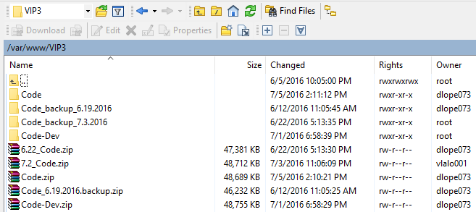

**Step 2:** Developer double checks that all configurations for VIP-Dev are in place. For example, make sure the port is set to 8001.

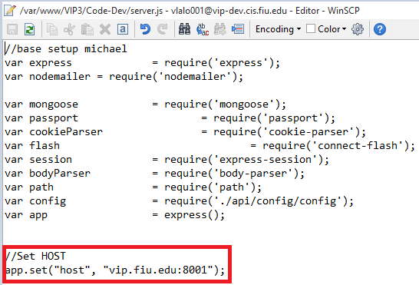

**Step 3:** Developer executes VIP-Dev server and checks to make sure the process is running

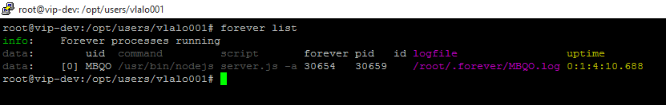

**Step 4:** Developer browses to the VIP-Dev URL in his/her web browser.

